*Integrating Crowdfunding with Blockchain Technology for Social Media Fundraising*

Justin v Kalappura

Master of Computer Application

Amal Jyothi College of Engineering Kottayam, Kerala, India [justin2023b@mca.ajce.in](mailto:justin2023b@mca.ajce.in)

Mr. Ajith G S

Master of Computer Application

Amal Jyothi College of Engineering Kottayam, Kerala, India gsajith@amaljyothi.ac.in

Abstract - Crowdfunding, a type of online fundraising, originated as a means of enabling individuals to donate modest sums of money towards supporting the creative and philanthropic endeavors of others, using an intermediary platform. The present concern with the mechanism of crowd funding pertains to the lack of transparency by intermediaries or platforms with respect to the funds provided by contributors for a particular cause. Furthermore, the current status of the project, including details such as the amount of money that has been collected thus far, the remaining sum to reach the goal, and the time left to attain the target, are frequently unknown and may remain unused. This article advances the notion of integrating a blockchain-enabled crowd funding component into a social media platform, thereby enhancing the opportunities for soliciting donations. The primary aim of this manuscript is to enable contributors to effectively contribute to a given venture through comprehensive understanding of its underlying cause. In order to ensure appropriate provision of resources, it is imperative to circumvent excessive financing. Integration with social media platforms presents a viable avenue for enhancing the likelihood of acquiring funds while simultaneously promoting accountability across the entire system and among its users.

# ***IndexTerms—Ethereum, smart contracts, crowdfunding****.*

# Introduction

Crowdfunding is a method of raising money from a large number of individual individuals or businesses. Investors can contribute to whatever project they choose and earn if it succeeds [1]. The popularity of crowdsourcing as a method to raise funds for charitable purposes or provide aid to individuals in need has significantly increased. Nevertheless, the deficiencies in the existing crowdfunding models with respect to accountability and transparency may potentially deter a subset of benefactors. This research paper proposes the integration of a blockchain-based crowdfunding mechanism into a social media network, as a potential solution to the aforementioned matter. The utilization of blockchain technology and smart contracts represents one of several approaches proffered to guarantee that transactions are properly allocated toward their intended objectives whilst simultaneously promoting transparency of the project's advancement to all relevant stakeholders, including the provision of current financial status. Collaboration with social media facilitates the expansion of the system's reach to a significantly larger audience, thereby heightening the likelihood of achieving smooth and successful fundraising efforts. The fundamental objective of this scholarly investigation is to establish a crowdfunding system that demonstrates higher levels of transparency and responsibility, thereby augmenting the probability of obtaining financial support for social media initiatives and causes. The proposed methodology ensures that donors possess accurate information pertaining to the cause they are contributing to through the integration of blockchain technology and smart contracts. This mitigates the risk of excessive funding and ensures optimal allocation of monetary resources. The present study endeavors to offer a comprehensive comprehension of the potential of blockchain technology and smart contracts in enhancing the crowdfunding process. The objective is to augment the transparency and accountability of the undertaking, and thereby, bolster the likelihood of successfully raising funds for creative and humanitarian initiatives. The proposed approach possesses the capacity to fundamentally revolutionize the crowdfunding industry, whilst simultaneously enhancing the well-being of individuals experiencing hardship.

.

# LITERATURE REVIEW

In order to address transparency, security, and accountability issues in the present crowdfunding platform systems Blockchain technology has find its own way. One study by Böhme et al. [2] highlights the potential of blockchain-based crowdfunding platforms to reduce information transperancy between investors and receivers. In that the writer proposes a blockchain-based crowdfunding platform, which leverages smart contracts to ensure that the funds are only recieved to the needed hands. Another study by Alsmadi et al. [3] proposes a blockchain-based crowdfunding platform will be a system that utilizes a decentralized application (DApp) to make sure the transparency and immutability in the fundraising process. The proposed platform employs a reputation system and a voting mechanism to help investors make informed investment decisions. Many researchers have also find the use of blockchain technology in correcting the problem of fraud activites happening in crowdfunding platforms. A study by Tran et al. [4] proposes a blockchain-based crowdfunding platform that leverages an escrow mechanism to minimize the risk of fraud. The platform utilizes smart contracts to hold the funds in escrow until the project initiator delivers the promised results. According to the writers argument they say that the platform provides a secure and transparent fundraising mechanism that is very efficient against fraud activites. Another challenge is the issue of scalability. Now also blockchain technology is in its early stages ie premature stages, and even the current networks can also only handle a limited number of transactions per second. This is a significant limitation for crowdfunding campaigns that require a large number of transactions. However, there are on going research happeneing in the field blockchain scalability is ongoing, and there are promising developments, such as sharding, that could address this issue in the future. (Swan, 2021) [5].

According to the analysis conducted by Zhu and Zhou [6], blockchain remains an emerging technology that is currently at the exploratory stage. Hence, a multitude of technical and legal factors need to be duly considered prior to its dissemination to the public. In the sphere of blockchain enterprise, it is apparent that there exists potential for further progress by means of cooperative endeavors amongst notable market actors and interested parties. The imperative objective is to facilitate the integration of blockchain technologies throughout the market, enable transformative change, and foster an environment conducive to the introduction of novel concepts. It is incumbent upon individuals to enhance their comprehension of blockchain innovation, including its value proposition, prospects, and potential drawbacks. It is imperative that efforts be made to promote the implementation of blockchain technology within the Chinese crowdfunding industry with efficacy. The attainment of financial competence and social benefits can be realized by means of technological progress and the utilization of blockchain-based applications.

# Methodology

In light of the complex regulatory landscape surrounding crowdfunding activities, the implementation of a smart contract represents a crucial means of achieving legal compliance across the multiple transactions involved in such activities. A smart contract comprises a well-defined and automated transaction protocol that facilitates the execution and regulation of transactions predicated on predetermined and mutually agreed terms between sponsors of a project and their financiers, while simultaneously documenting the same. The proposed methodology entails the implementation of dual contractual agreements - one for the purpose of housing all projects and another dedicated to the oversight of transactions specific to each project. The cardinal elements involved in a crowdfunding platform comprise of project administrators, patrons, suppliers, automated agreements, and expenditure petitions. Crowdfunding is a multi-stage process that involves three distinct phases.

A. System user:

Here we integrate this crowdfunding feature to a social media platform. In the prescribed system, the crowdfunding feature and the rest of the social media has been made in such a way that they are not connected to each other. So in order to use the crowdfunding functionality. They should be the user of two things:

## i. Socialmedia User

The first thing they has to do is that they should be a user of the social media. This functionality is only provided to this particular social media users. In order to use this functionality they not only needed to be the user but also needed the second thing to be done. That is mentioned below.

## ii. Ethereum Network user

The final they need to do in order to use this functionality is that they need to have an account in meta mask with sufficient amount of coins in the corresponding blockchain. Here it is the coin Eth, which is the coin of the Ethreum blockchain.  
  
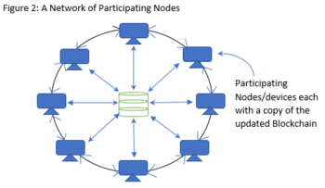

B. Project creation:

After the completion of first step, now you can use this functionality of crowdfunding for rest two purposes ie for creating a project and contributing to the project. In this the thing that you can do is that you can create the project with full details needed. In order to create a project you can do it by providing the details such name of the project, details about the project, target amount for the project, target date for the project. Once your have created the project it will be given in the common crowdfunding platform of the social media. So after the creation of the project, if you visit the you profile in the account you can see your own created projects over there.

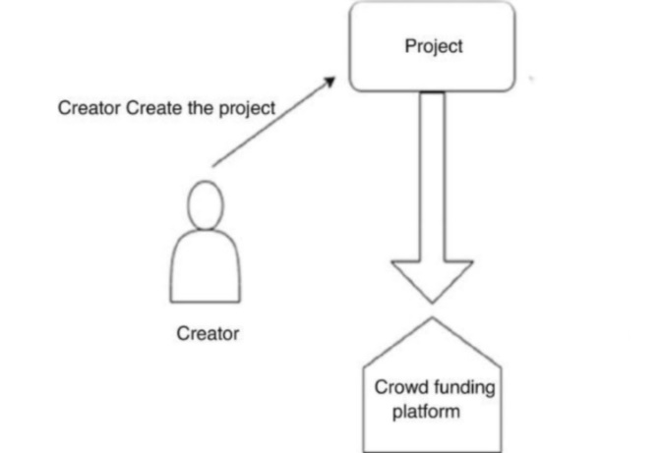

C. Contribute to project:

The last thing is that you can contribute to the interested projects mentioned or posted by other users on to the platform. The full details related with the projects will be mentioned in the project so that we can find the most needed one and contribute to them with respect to our interst too. In order to contribute to any project we need to have the corresponding coin of the blockchain in which it is running here it is Eth. According to Gebert (2018), the utilization and significance of blockchain technology in crowdfunding is particularly noteworthy for small-scale businesses due to the continuous threat of employment uncertainty faced by startups. Consequently, there is a pressing need for governmental bodies to facilitate small business enterprises' access to financial resources. The European region has not achieved success in regards to crowdfunding due to an unfavorable government environment. Small-scale businesses require funding to maintain their operations; consequently, the emergence of crowdfunding platforms is crucial to their growth. The advancement of blockchain technology presents a promising outlook for the potential growth and enhancement of our proposed project. In subsequent phases, the research endeavor may be advanced more seamlessly and with enhanced safety protocols, in order to accommodate a wider range of innovative concepts generated via the envisioned crowdfunding platform.

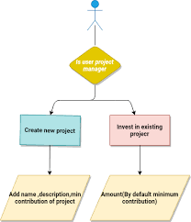

# IMPLEMENTATION AND RESULT:

In order to operationalize the crowdfunding platform, a solidly scripted smart contract written in the Solidity programming language is a necessary requirement. Subsequently, the aforementioned program is compiled and deployed onto the Ethereum blockchain utilizing the Solidity compiler. The use of Metamask, a browser extension for Chrome, facilitates the execution of all transactions.

Procedure for modeling a crowd funding platform:

**Step 1:** Smart contract creation.

The present software application has been authored using the programming language Solidity, and is designed to enable the automatic execution of transactions. Prior to commencing, potential users are required to establish a project through the provision of its designated title, comprehensive description, minimum contribution requisites, as well as a target deadline amongst other pertinent details. Investors are entitled to generate spending proposals that necessitate supplying an explicit description of the intended allocation of funds, the corresponding expenditure amount, and the vendor's physical address. If a majority of the investors consent to the expenditure proposal, the manager overseeing the project is authorized to allocate the funds to the vendor, who is responsible for delivering the desired service. Investors may become project participants by making a contribution that complies with the established minimum amount prescribed by the project leader. The monetary funds are transferred to the project initiator's account and the contributors are given the opportunity to receive the monetary compensation offered.

**Step 2:** Bytecode deployment to the Ethereum blockchain

The Compiler generates two distinct forms of output, namely bytecode and application binary interface (ABI). The bytecode refers to a hexadecimal representation of the compiled contract that possesses exclusive interpretive capabilities by the Ethereum Virtual Machine (EVM). Upon acquiring the bytecode, it may be consequently disseminated to any of the three Ethereum networks namely Rinkeby, Goerli, or the main network. After the deployment is successful, the network will return an address for the smart contract, which the users uses to interact with the smart contract and make transactions. Solidity written smart contract is compiled using a compiler that gives two particular outputs: bytecode and ABI. The bytecode is a code that only the Ethereum Virtual Machine can read and is deployed to one of the three Ethereum networks. Once deployed, the network returns an address for the smart contract, which allows users to interact with the contract and make transactions.

**Step 3:** Integrate crowdfunding as a feature to the Social media

Now we need to integrate this crowdfunding module to our social media. This is done to make the all users get an equal opportunity of having an option for getting funded for their causes. And also an opportunity to contribute for others genuine causes with the proper knowledge of their financial status. The main use of implementing this crowdfunding feature to the social media is that it will increase the financial donations to the causes of the normal common human. The only thing they need to do is that they should be a user of this particular social media.  
  


(i)List of campaigns users created



(ii) Create campaign

# CONCLUSION

Blockchain technology implemented crowdfunding can provide greater transparency and accountability to the system, which is currently lacking in traditional crowdfunding platforms. The proposed blockchain-based crowdfunding feature implemented to a social media platform can increase the chances of successfully raising funds for a cause. The use of smart contracts and Ethereum blockchain technology can help automate and execute transactions securely, transparently, and efficiently. This can help prevent overfunding and ensure that the funds are used for their intended purpose. The integration of this feature with a social media platform can help promote crowdfunding campaigns and increase their visibility. Hence, we can conclude that in this research we proposes a solution to the existing issues in the crowdfunding system and offers a more secure, transparent, and accountable solution for users.

# REFERENCES

1. https://www.investopedia.com/terms/c/crowdfunding.as
2. R. Böhme, N. Christin, B. Edelman, and T. Moore, "Bitcoin: Economics, Technology, and Governance," Journal of Economic Perspectives, vol. 29, no. 2, pp. 213-238, 2015.
3. H. Alsmadi, A. Elchouemi, and A. Bendahhou, "Blockchain technology for crowdfunding: A decentralized approach," Journal of Theoretical and Applied Information Technology, vol. 97, no. 8, pp. 2094-2106, 2019.
4. T. Tran, N. Niyato, P. Wang, D. I. Kim, and D. N. Nguyen, "A Blockchain-Based Crowdfunding Framework for Sustainable and Socially Responsible Projects," IEEE Transactions on Engineering Management, vol. 66
5. Swan, M. (2021). Blockchain: Blueprint for a New Economy. O'Reilly Media, Inc.
6. Zhu, H., Zhou, Z.Z. “Analysis and outlook of applications of blockchain technology to equity crowdfunding in China,” Financ Innov, 2016
7. Gebert, Michael, “Application of blockchain technology in crowdfunding,” New European.